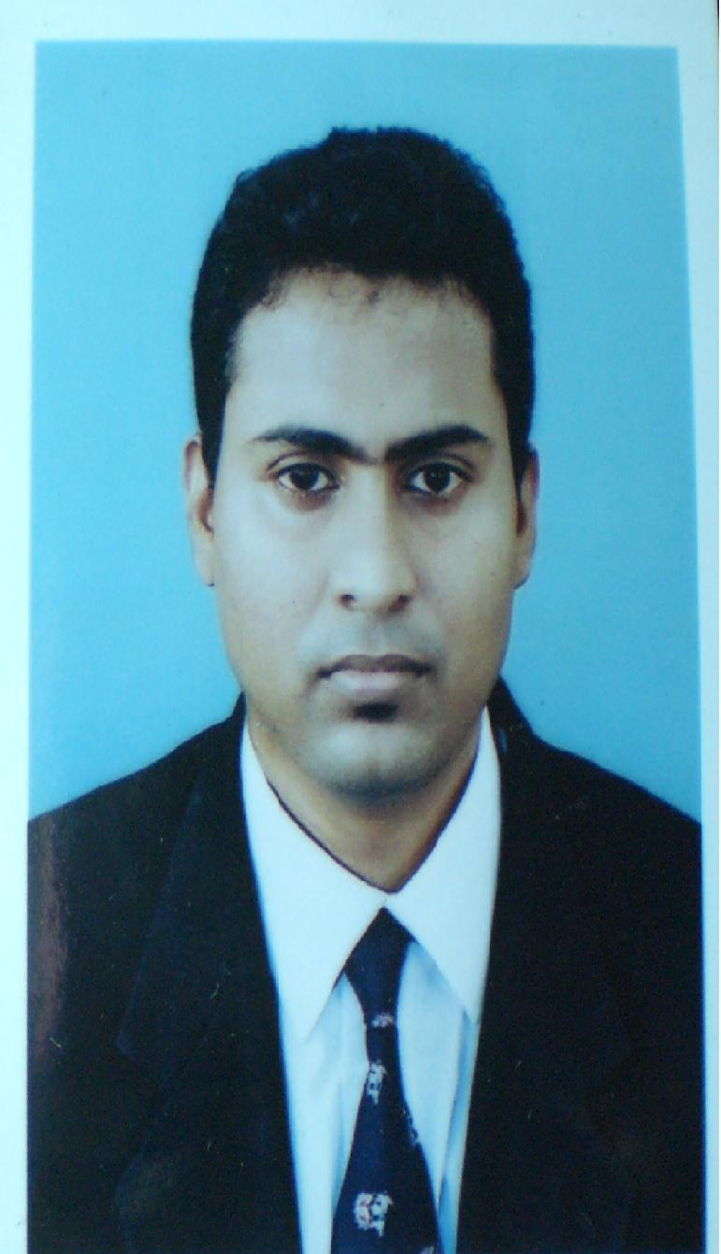

ARAVINDA P.H.THUDUWAGE
465/2, Thalahena, Aritigala Rd,
Meegoda.
Mobile: 0766787247
Home : 0112751155
E Mail: aravindapushpakumara1@gmail.com

EMPLOYMENT
Name of the organization : Park Hyatt – Abu Dhabi

Positions & Period :Laundry Attendant
Apr 2013 - Nov 2014

Name of the organization : Park Hyatt – Abu Dhabi

Positions & Period : Bell Boy Attendant – (On training)
Sep 2014 – Oct 2014

Name of the organization : Waquis Private Limited – Sri Lanka

Positions : Mortgage Data Processor

Name of the organization : IRIS SOLUTIONS PVT .LTD

Positions : Data Entry Operator

EDUCATIONAL QUALIFICATION

I am following aat exam- (Association of Accounting Technicians of Srilanka)

General Certificate of Education (Ordinary Level) Examination, 2002

Subject Grade
- Accounting & Business Studies A
- Religion-Buddhism B
- Social Studies B
- Sinhala C
- Mathematics C
- Science C
- English C
- Development Studies C
- Art S

  - I have won 1st Price for Mathematics in grade 9.

General Certificate of Education (Advanced Level) Examination, 2005

Economics S
Business Studies S
English S

COMPUTER LITERACY

Microsoft Office 2007

ROLES / LEADERSHIP

- Senior colures men for rugby.
- Vice Captained 1st xv Ruby team 2004.
- Represented the school under 15 Rugby team which emerged All Island Plate
Championship.
- I have awarded with certificate of merit for being a member of the Semi Final
team in the Premier Rugby Trophy 2004.
- Member of school Health society.
- Member of school Literary Association.
- Member of school Buddhists society

PERSONAL INFORMATION

        - Date of Birth : 14th May 1986

        - Civil Status : Single

        - Nationality : Sri Lankan

        - Language : English, Sinhala, (Speaking and writing)

REFERENCES

Anura Priyashantha Amali Jayamanne
Laundry Manager General Accountant
Park Hyatt Abu Dhabi. Crowne Plaza & Stay Bridge Suites Yas Island Abu Dhabi
Mobile : +971502764146 Mobile: +971505727721
E-mail : anura.priyashantha@hyatt.com E-mail : amali.jayamanne@ihg,com

